SCE301 Bio-computation Week 5 Lab Exercises, 2016

Multi-layer Perceptrons (MLP) with BP Training

Prepared by Bailing Zhang

Part 1. Practices on MLP by using Matlab NN Toolbox

Exercise 1.
The example program (demo1) demonstrates the capability of an MLP to model the
XOR logic gate. Open the demo1.m program and then go through it. There are 4
clusters of data (A,B,C,D) are defined in a 2-dimensional input space. (A,C) and (B,D)
clusters represent XOR classification problem.
Experiment with different number of training passes, input-output configurations, etc.

Exercise 2.
In this exercise, you are required to demonstrate the capability of an MLP to approximate the function
f(t) = sin(t)*exp(-t/20); 0 < t < 50
Experiment with varying the number and location of training data points, number of hidden layers and nodes, etc. What are your conclusions?

Part II MLP model for the printed digits classification

You are given a set of printed digits (0-5) (training and testing). Each digit is in binary format. After using imread to load an image into memory (e.g., im=imread('0a.bmp') ), you can display the image using imshow command. Then the image matrix can be changed into a vector by simply using x=im(:).

Collect the training images into a training data matrix X and their corresponding labels' coding (target), e.g.,

1 -> 001

2-> 010

3-> 011

4-> 110

5-> 111

Collect the targets into Y. Then compare the classification performance of perceptron with error correction rule, Sigmoidal perceptron with gradient descent algorithm, and MLP.

Note: After training, the MLP network should be simulated using the function sim, i.e. >> y = sim(net, x);
Where x is the testing data
Measurement of the rate of correct classified vectors can be done as follows
>> rate(getcls(y), t);

Try to classify all training vectors (using sim) and record the classification result (using getcls and rate) and the mean squared error (MSE). Do 10 calls to train. After each call, classify the training vectors and record the result. The network should perform better and better.

Make a table where you record the number of epochs, the mean squared error (MSE) and the classification result (using rate), like this:
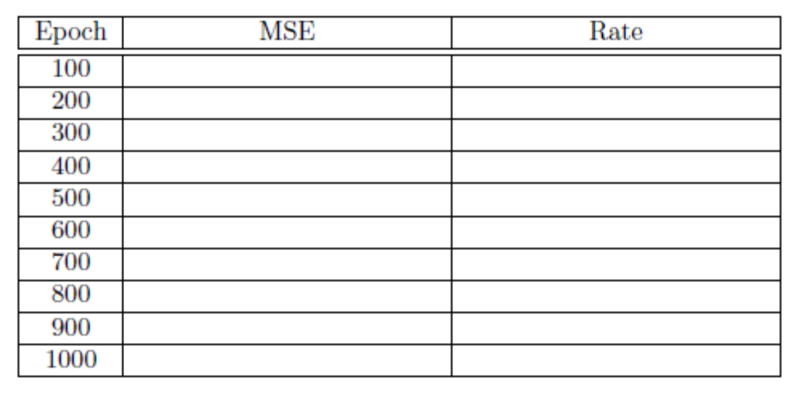
Comment on the result (e.g., does the MSE/Rate go up or down? sometimes or usually or always??) Note that sometimes the training might get stuck in a local minimum — if this happens, you have to reinitialize the network and start the training again.

